Ms Ursula von der Leyen
President of the European Commission
200, rue de la Loi
BE – 1049 Brussels

Brussels, 31 January 2024

Re: Half of Member States face farming protests - It's up to the EU to respond to this emergency!

Dear President of the European Commission,
Today, we must listen to the echoes that are reverberating throughout our countryside from the West to the East of Europe. Farming communities are facing enormous challenges and pressures, which have only accumulated in recent years.
Madam President, if you meet with farmers in the next few days, you will be able to hear what they have in common. Economic burdens and bureaucracy are strangling farmers across the EU. Across the EU, the effects of climatic and geopolitical crises are impacting our farms considerably. And all this with the feeling that more constraints and more European regulations are going to be imposed on farms with severe and irreversible consequences on productions, income and increase of imports with less environmental and social standards.
Over the last few years, we've spoken out vigorously, but we haven't been heard! As a result, the situation is currently very tense in many Member States, with farmers taking to the streets, as the survival of the European family farming as it is known today, is in danger.
With your State of the Union speech on 13 September 2023, you proposed a Strategic Dialogue on the future of agriculture to engage in “more dialogue and less polarization” and to abandon the “top-down approach’ of the Green Deal and Farm to Fork Strategy.
Dialogue is essential, and we welcome the fact that the farming community is part of the strategic dialogue, and we hope to be listened to and understood. However, we know that this discussion will focus on proposals and solutions for the long-term and for the new European Commission.
Today, all members of Copa and Cogeca are saying that there is an urgent need to provide short-term answers to the questions posed by the thousands of farmers who are demonstrating their distress and lack of understanding for various months now:
- to finally decide on the much-needed derogations to the CAP conditionality (e.g. GAEC 6, 7 and 8), eco-schemes and agri-environment-climate commitments which build on this, for 2024. We need a common action to address these severe difficulties.
- to adapt the next Ukraine Autonomous Trade Measures (ATMs) proposal by creating a system ensuring that the destination for all consignments of Ukrainian agricultural products is determined prior to entry into the EU and introduce a system to guarantee that the Ukrainian products reach this final destination and do not end up elsewhere. Plus, the introduction of import thresholds for any agricultural commodity subject to trade liberalization based on the yearly or quarterly average for the combined years 2021 and 2022.

- to ensure reciprocity in farm production standards and a level playing field to ensure fair trade. Trade preoccupations go far beyond the impacts of trade liberalization with Ukraine. In that sense the Mercosur agreement is unacceptable for most EU farmers; at this moment, a continuous push for getting the deal across the line will be perceived as a further provocation by the farming community and will increase the rejection for decisions taken by the European Commission.
European agriculture is the most sustainable model in the world. Farmers and agri-cooperatives are essential for food and energy supply chains, crucial in the current geopolitical context and deserve to be recognised as strategic.
With being a few months away from pivotal elections for the future of Europe, the farming community, who is the main actor of the first European Common Policy is expecting a reaction from the European executive to be able to continue their activities in acceptable conditions, with decent incomes and less administrative burdens.
We remain at your disposal to exchange in the coming days and weeks. We are asking for a meeting with you together with our farmers and agri-cooperative members.
Yours faithfully,

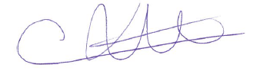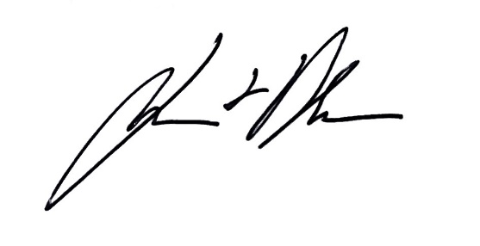
Christiane Lambert Lennart Nilsson
President of Copa President of Cogeca

